UP-PF自驾仪简介
UP-PF Autopilot
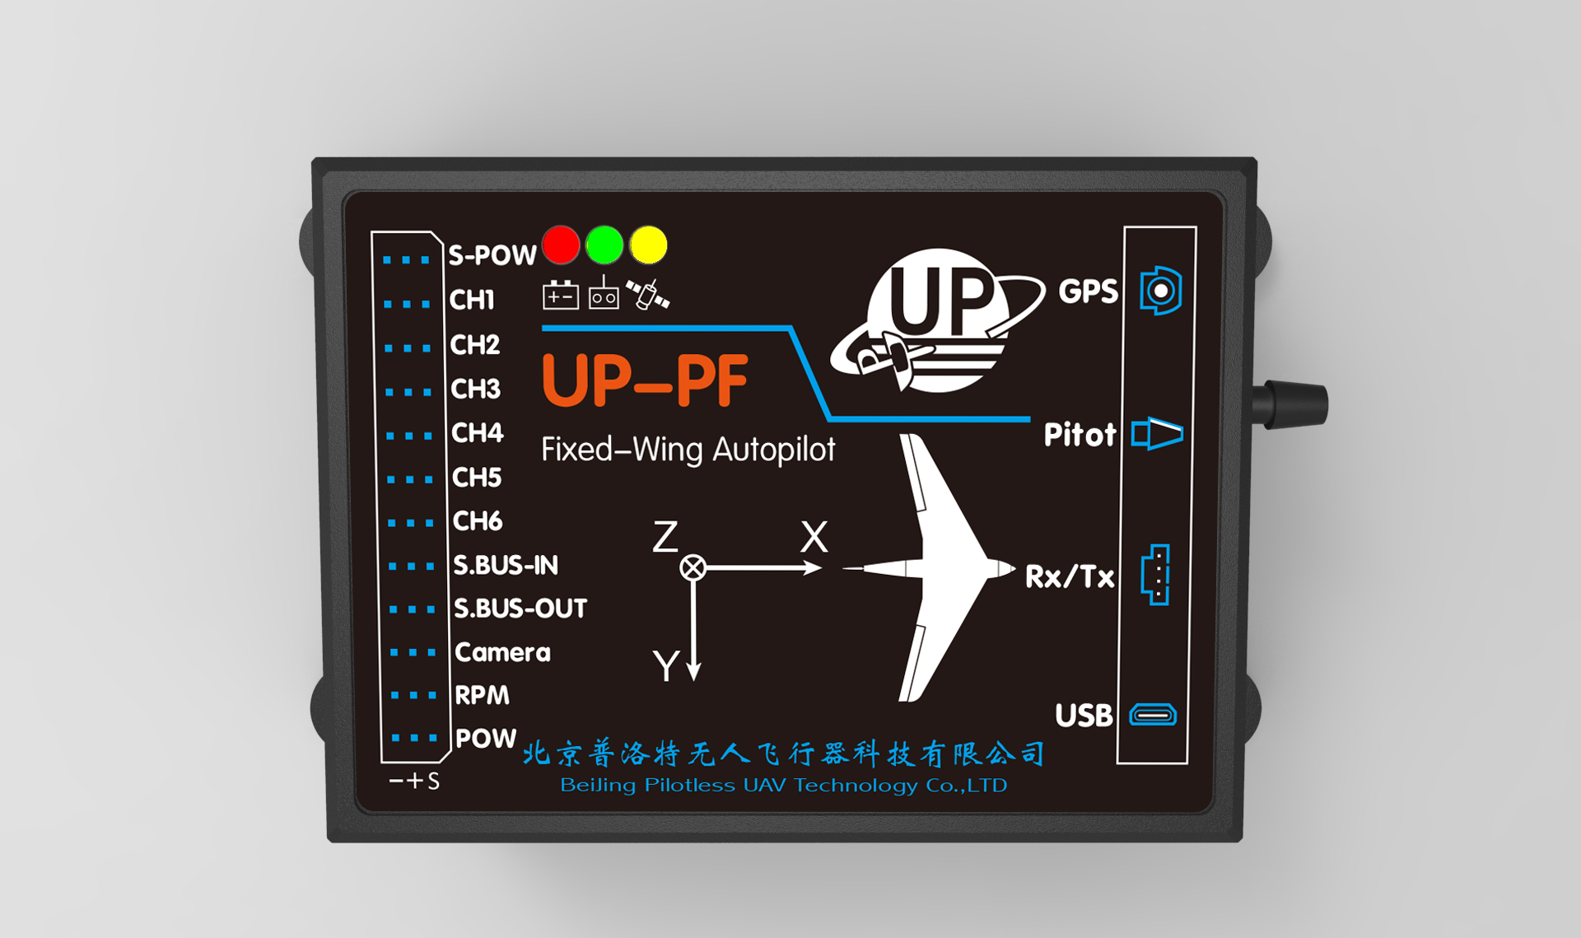
简介
UP-PF是UP系列一款面向模型爱好者开发的固定翼模型飞机自动驾驶仪。安装到固定翼无人机上之后，可以通过手机、游戏机手柄或者遥控器以半自主模式操控飞机，甚至可以进行超视距飞行，距离FPV飞行。在意外失去通讯后可自动恢复到全自动飞行模式。也可使用手机或者游戏机手柄做一键自动横滚、筋斗、倒飞等在自驾仪安全操控下的特技飞行。系统包括：机载飞控，地面站软件，手机APP软件，蓝牙盒子和通讯电台。UP-PF可以控制各种动力的固定翼布局机型。遥控器可以一键从纯遥控模式转到半自主模式，使飞机从任意姿态恢复到定高平飞状态，此功能可做初学者的教练功能。自动导航模式下，在地面站或者手机APP地图上可以随意设置飞行路线和航点，支持飞行中实时修改飞行航点和更改飞行目标点。具备一键自动起飞，一键伞降的功能。也可在地面站或手机地图上指点飞行。
UP-PF is a member of UP fixed-wing UAV autopilot family developed for model enthusiasts. When installed on fixed-wing UAV, users can use Android mobile phones, game controller or remote to control UAV in semi-autonomous mode. With UP-PF, UAV can even fly beyond visual range, and make long-distance FPV flight. UAV can also automatically tunes to full autonomous flight mode in case it loses communication with its ground station. You can also use cell phone or game controller to make one-key automatic roll, somersault flight, inverted flight and other aerobatics. UP-PF System contains: airborne flight controller, ground station software, Android cell phone App, blue-tooth box and transmitter. UP-PF can control fixed- wing model with any kind of engine and at varied layouts. Press one key on the remote control, the UAV can revert to semi-autonomous mode from full remote mode, which enables UAV to adjust to level flight at programmed attitude from any flying pose. This feature is especially useful for beginners. In automatic navigation mode, user can set flight routes or way-points freely on the map of ground station or mobile APP. It can also realize real-time changes in flight way-points and target point. UP-PF also has one-key automatic take-off and one-key parachute landing function. UPV can also fly to any waypoint pointed at the ground station or mobile flight map.
遥控器
Remote

- 使用，Futaba SBUS系列遥控器接收机，具备16个比例通道和2个开关通道同时输入的功能，仅使用3根线与自驾仪连接。
- Futaba SBUS receiver is used, support simultaneously imputing from 16 portion channels and 2 switch channels. Only 3 wires are needed to connect to autopilot.
- 若选配PWM转SBUS模块，此硬件兼容所有型号接收机，可使用所有型号的遥控器。
- With provided module for converting PWM to SBUS, UP-PF is suitable for all types of receivers and remotes.

飞控舵机控制
Servo control
- 6个舵机通道
- 6 servos channels
- 可扩展18路SBUS舵机
- Can be scalable to 18 SUBS servos
- 混控功能
Mixed control function

- 襟副翼
- 升降舵方向舵交联，此模式可以控制V尾。
- 副翼升降舵交联，此模式可以控制飞翼或者无尾飞机。
- Flaperon mode
- Cross link elevator and rudder for V-tail mode control
- Cross link aileron and elevator for flying wing or tailless aircraft control
航线：
Route
- 可设置20个3维航点
- Support 20 3D waypoints setting
- 可以绕航点顺时针或逆时针做环状飞行，可自行设定环绕半径。
- Set wanted radius and you can fly surround a waypoint clockwise or counterclockwise

- 可设定Home点环绕高度与半径。
- Support home point (take-off point), surround fly altitude and radius setting
- 航线具备循环模式和单次航线飞行模式（通过设置1点是否具备环绕飞行）
- Can be set cycle mode or single mode(by setting the first waypoint surround flight or not)

- 指点飞行模式。
- UPV can fly to any waypoint pointed at the flight map and fly surround this temporary waypoint.

在UAV模式下，地图上直接点击临时需要飞往的航点，并绕航点进行环绕飞行。
手机和游戏杆半自主遥控模式：
Semi-autonomous mode
( with Android phone or joystick)
- 升降杆在飞行中控制目标高度（当前高度正负60米）
- Elevator stick controls target altitude during flight(±60m of current altitude)
- 升降杆在降落时可控制俯仰角（正负15度）
- Elevator stick controls pitch angle when landing（±15°）
- 副翼杆控制滚装角度（最大60度）
Aileron stick controls roll angle ( maximum 60°)
- 一键回家
One key home
- 一键降落模式停、开电机
- One key stop or start
- 一键伞降
- One key parachute
- 一键自动筋斗
- One key somersault
- 一键自动横滚
- One key roll
- 一键切换倒飞正飞模式
- One key upside/down switch

遥控器飞行控制模式
Remote control mode
- 可在RC（纯手动遥控模式）、RPV（半自助控制模式）、UAV（全自动航线飞行模式）自由切换
Smooth switch among RC mode(remote control mode), RPV mode(semi-autonomous control mode) and UAV mode(automatic flight mode)
- 半自主飞行模式下
- Semi-autonomous mode
- 升降杆可控制俯仰角或者目标高度
1. Elevator stick controls pitch angle and target altitude
- 副翼杆控制滚装角度
2. Aileron stick controls roll angle
3. 油门杆控制油门或空速
3. Throttle lever controls throttle or airspeed

任务能力
Ability
- 相机控制
- Automatic camera control
控制相机电子快门按照定时或者定距离自动拍照；也可以手动拍照
Camera can be controlled to take pictures at set time or distance. Manual photoing is also available.

物理参数
Physical parameters
- 重量
- Weight
- 飞控板：18克
- Autopilot: 18 g
飞控盒：30克
- Box: 30 g
- 飞控盒尺寸：67x40x22 mm
- Box Size:67×40×22 mm
- 宽输入自驾仪电源：100mA@7.2V, 输入范围 5V 至 32V
- Main input power: 100mA@7.2V, input range: 6V~32V
- 自驾仪电源电压监视
- Main power voltage monitoring
- 舵机电源电压监视
- Servo power voltage monitoring

通讯设备
Communication tools
- 数传通讯设备
- 433Mhz,9600bps，500mw
Transmitter-receiver: 433MHz, 9600bps, 500mW
通讯距离大于2.5公里，自动航线距离5公里
- Communication distance: ≥2.5km
Automatic route distance: 5km

地面站及手机软件
Ground station and Android phone App
- 设置飞机飞行参数
- 实时监控飞行数据，显示飞机的飞行轨迹（5Hz）
- 图形化方便灵活的航点编辑方式
可以直接在地图上使用鼠标增加、删除航点，可以直接拖动编辑所选择的批量航点，可以手动修改航点数据。支持单点和所有航点上传和下载。
- 危险告警(电压、GPS状况、发动机转速、高度、爬升率等)
- 可以下载保存飞机配置信息，同一飞控在不同飞机间更换，只需上传恢复原下载的配置数据即可
- Setting flight parameters
- Real-time flight data monitoring and display of flight trajectory(5Hz)
- Graphic waypoint edit mode
User can add or delete waypoints on the map, and drag selected waypoints directly, modify waypoint data manually. And it also support single waypoint or all waypoints upload and download.
- Alarm function
Alarm when in dangerous state (voltage, GPS status, engine speed, altitude, rate of climb)
- User can download and save aircraft configuration information, and can upload the downloaded configuration data when install the same autopilot to a different aircraft.

